**ASSIGNMENT 04 – WordPress CMS Website**

**Instructions for completing template:**Replace **[bracketed red text]** with the requested information or screen capture.  
Replace **bracketed red text with black text**.  
Do not include full screen shot images, or full screen shots that are reduced in size. Use a snippet tool to capture parts of the screen and insert those images into the template.  
Do not remove tags (tag example [C01]) from this template. Please fill out all items and answer all questions. Please do not alter template formatting or delete parts of this template.

Part A - Student Information:   
 **1. Student Name: [SYED AFTAABUDDIN]**

**2. Phone: [773-796-0029]**

**3. Email: [syedaftab299@gmail.com]**

Go back to the instructions and continue with Part B.Part B1- Shared Web Host WP CMS Website Information:

Shared Web Host Name: [Namecheap] [B1.01]  
Shared Web Host URL: [www.namecheap.com] [B1.02]  
Shared Web Host Site Admin Username: [saftaabu] [B1.03]   
Shared Web Host Site Admin Password: [50297006@Sps] [B1.04]

Website Admin Username: [saftaabu] [B1.05]  
Website Admin Password: [W7l&@O8yJnlIq] [B1.06]  
Database Name: [wp832] [B1.07]  
Table Prefix: [wpo5_] [B1.08]  
WordPress CMS Website URL: [http://syedaftab.tech/mod4assig4/] [B1.09]

-OR-  
Part B2- Pantheon WP CMS Website Information:  
**Assignment Website Site Name:** **[Site Name]** [B2.01] **Assignment Website Frontend URL:** **[WEBSITE FRONTEND URL]** [B2.02] **Website Admin Username:** **[ADMIN USERNAME]** [B2.03] **Website Admin Password:** **[ADMIN PASSWORD]** [B2.04]

Go back to the instructions and continue with Part C.

**Part C - WordPress CMS + Website Extensions + Comments**

1. Backend Screen capture of the dashboard > Themes   
   [C01] **[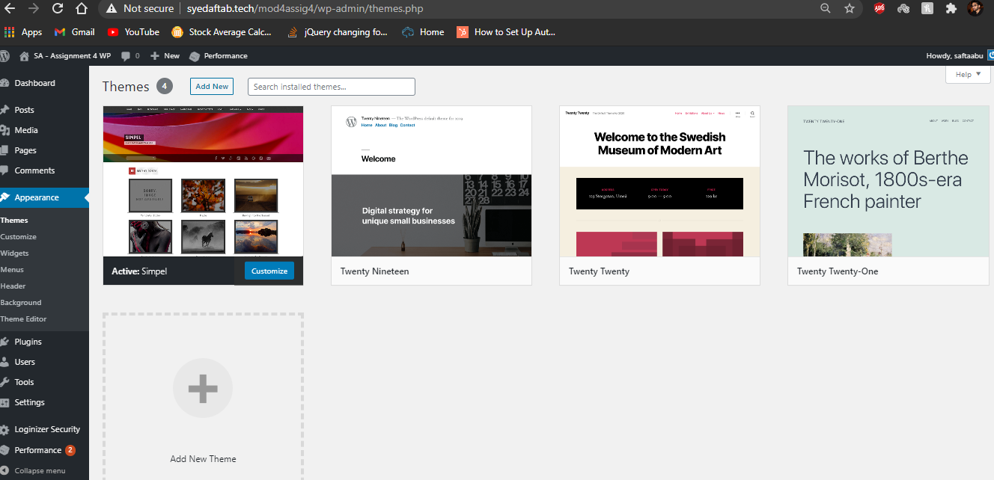]**
2. Backend Screen capture of the dashboard > Plugins   
   [C02] **[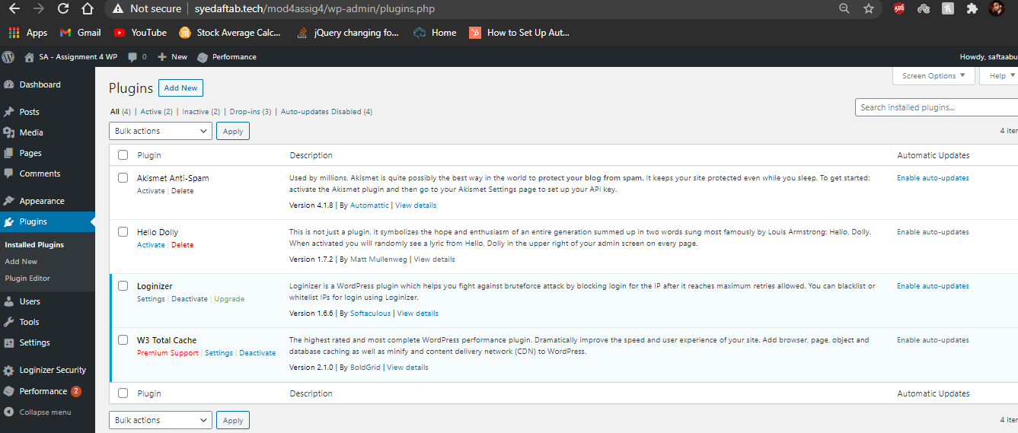]**
3. Backend Screen capture of the dashboard > Media library page with List view selected  
   **[**C03] **[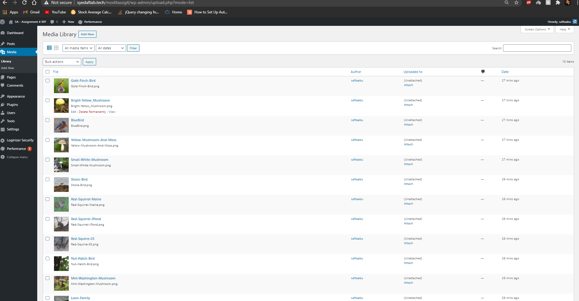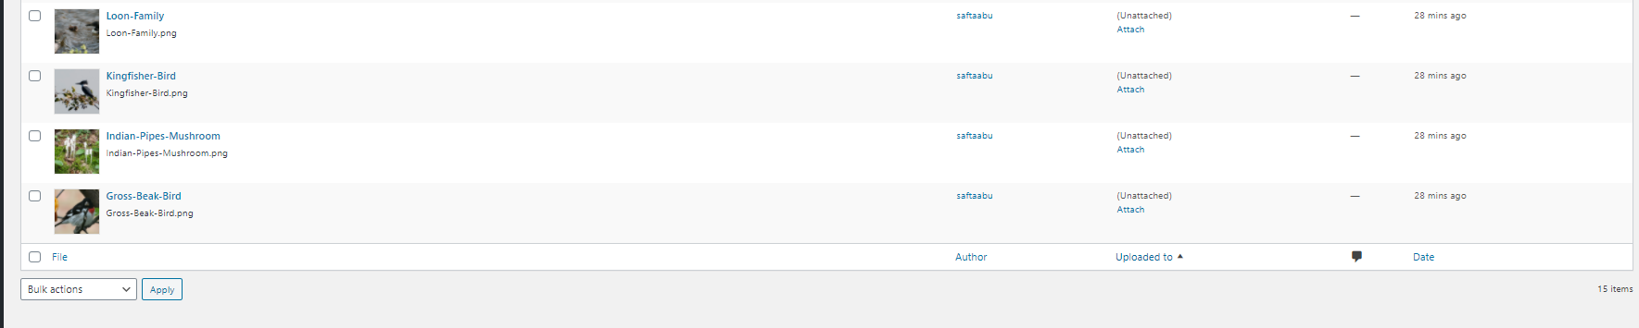]**
4. Backend Screen capture of the dashboard > Menu page   
   [C04] **[  
   [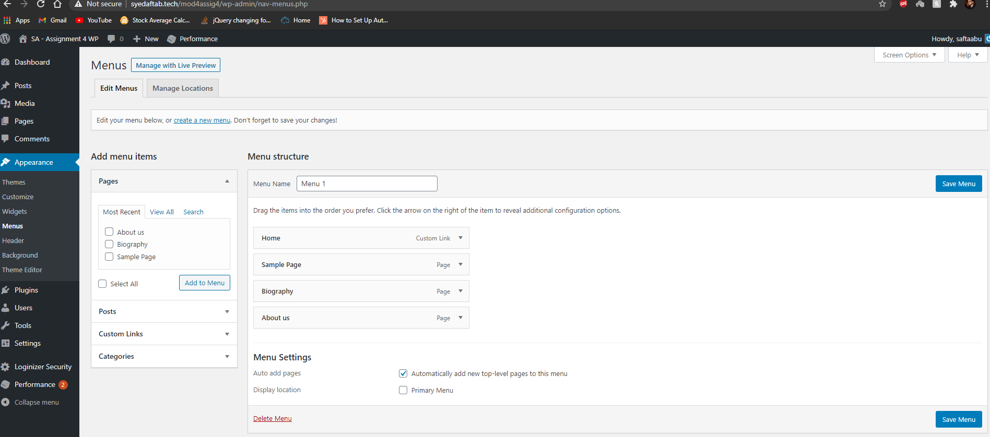]**
5. Backend Screen capture of the dashboard > Posts > Categories  
   [C05] **[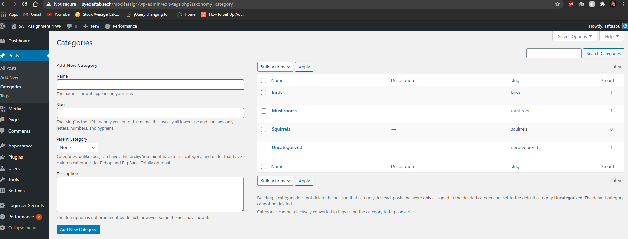]**
6. Backend Screen capture of the dashboard > Post > Tags   
   [C06] **[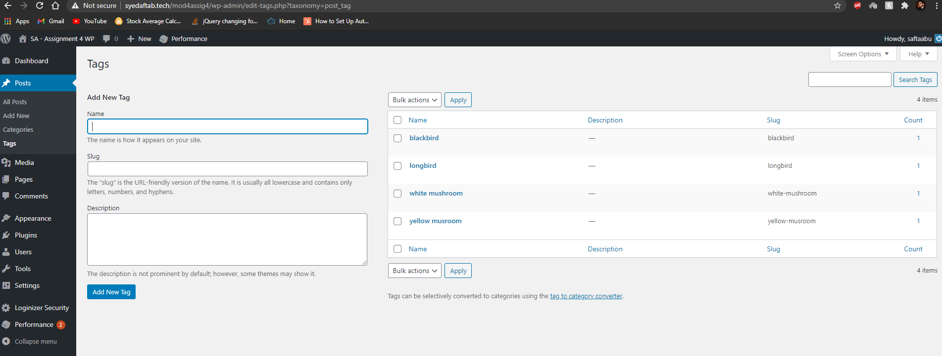]**
7. Backend Screen capture of the dashboard > Posts (showing comments in the list)  
   [C07] **[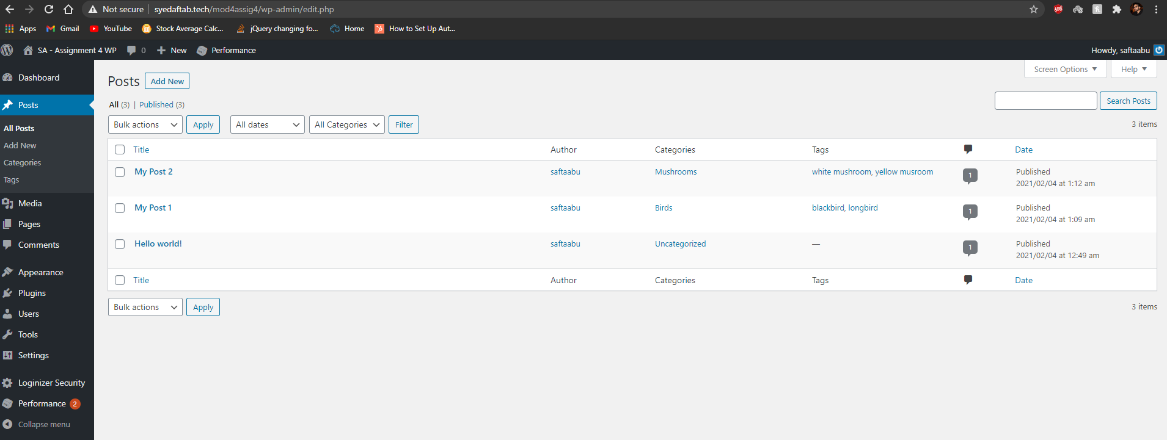]**
8. Backend Screen capture of the dashboard > Pages (showing comments in the list)  
   [C08] **[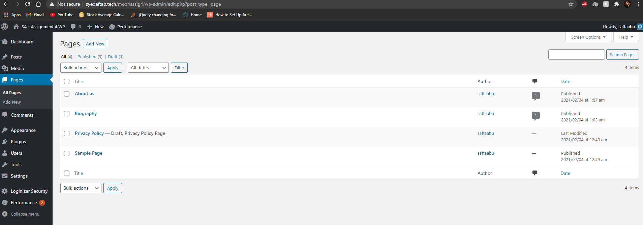]**
9. Screen capture website front-end showing menu with the “Biography” page selected and displayed  
   [C09] **[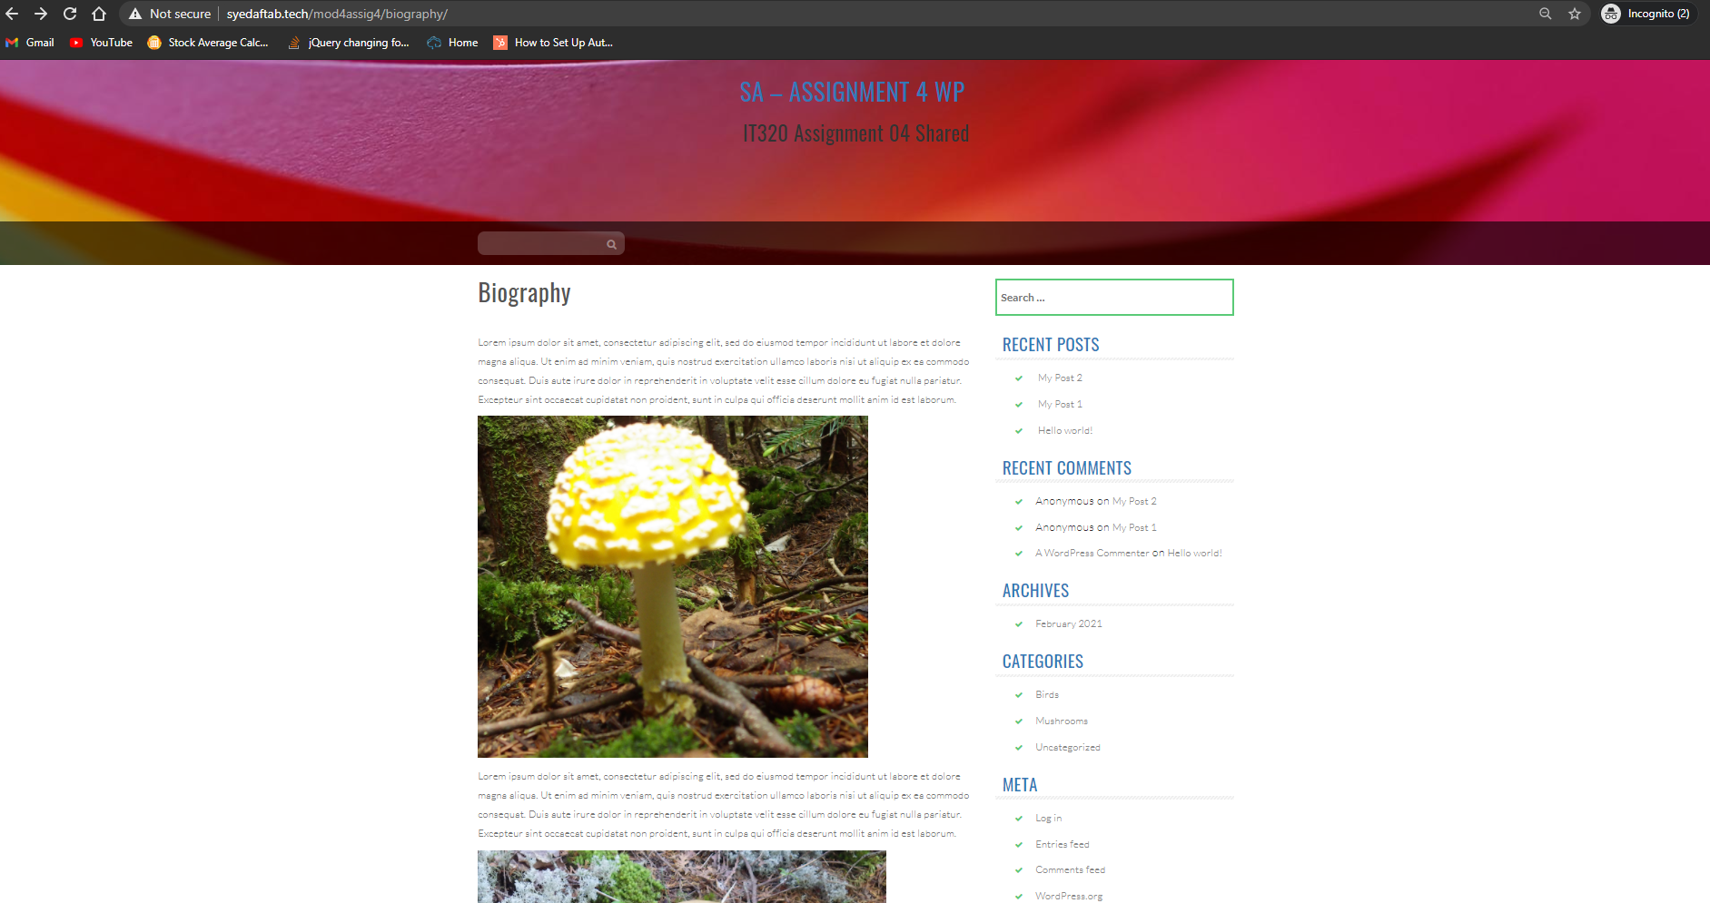]**
10. Screen capture website front-end showing menu with the “About us” page selected and displayed  
    [C10] **[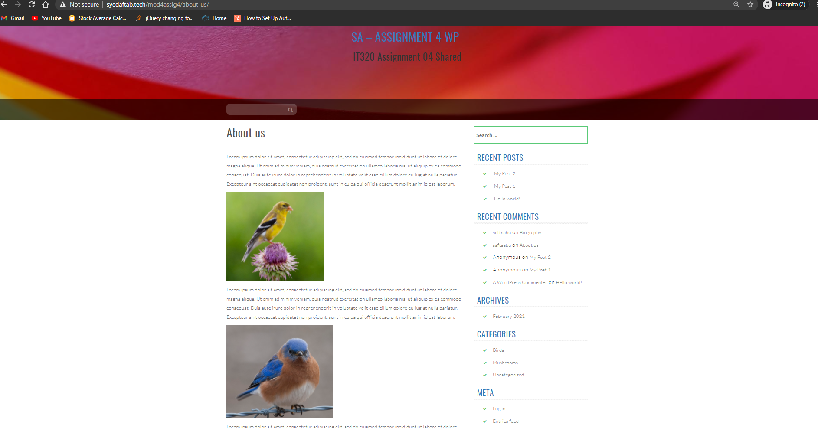]**
11. Screen capture website front-end showing Home page with the first Post visible with Categories and Tags visible on the screen capture.   
    [C11] **[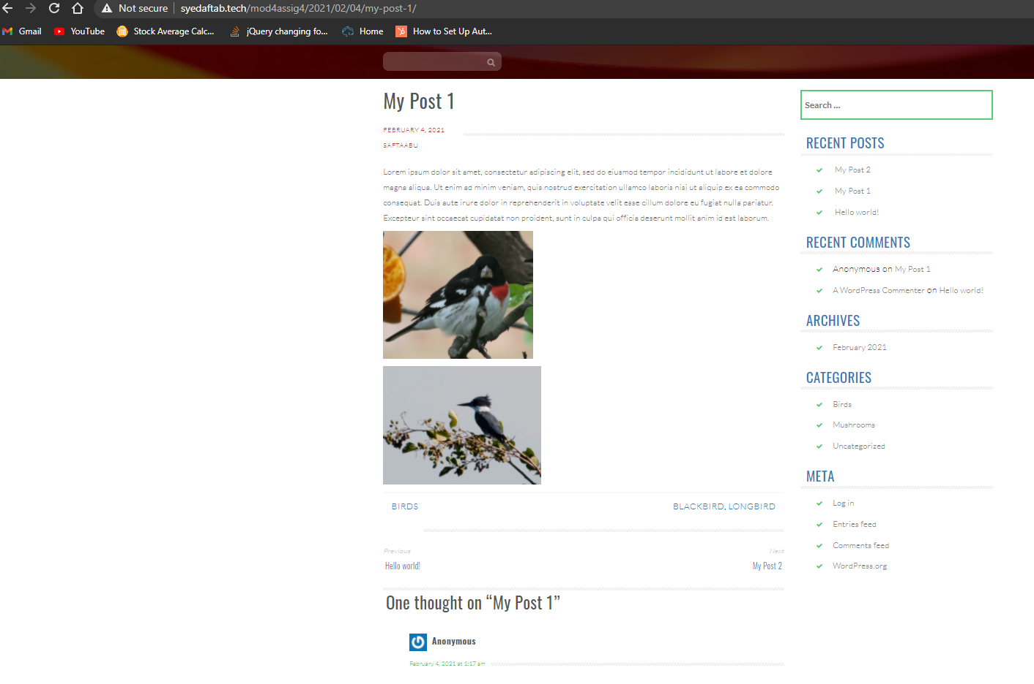]**
12. Screen capture website front-end showing Home page with the second Post visible with Categories and Tags visible on the screen capture.  
    [C12] **[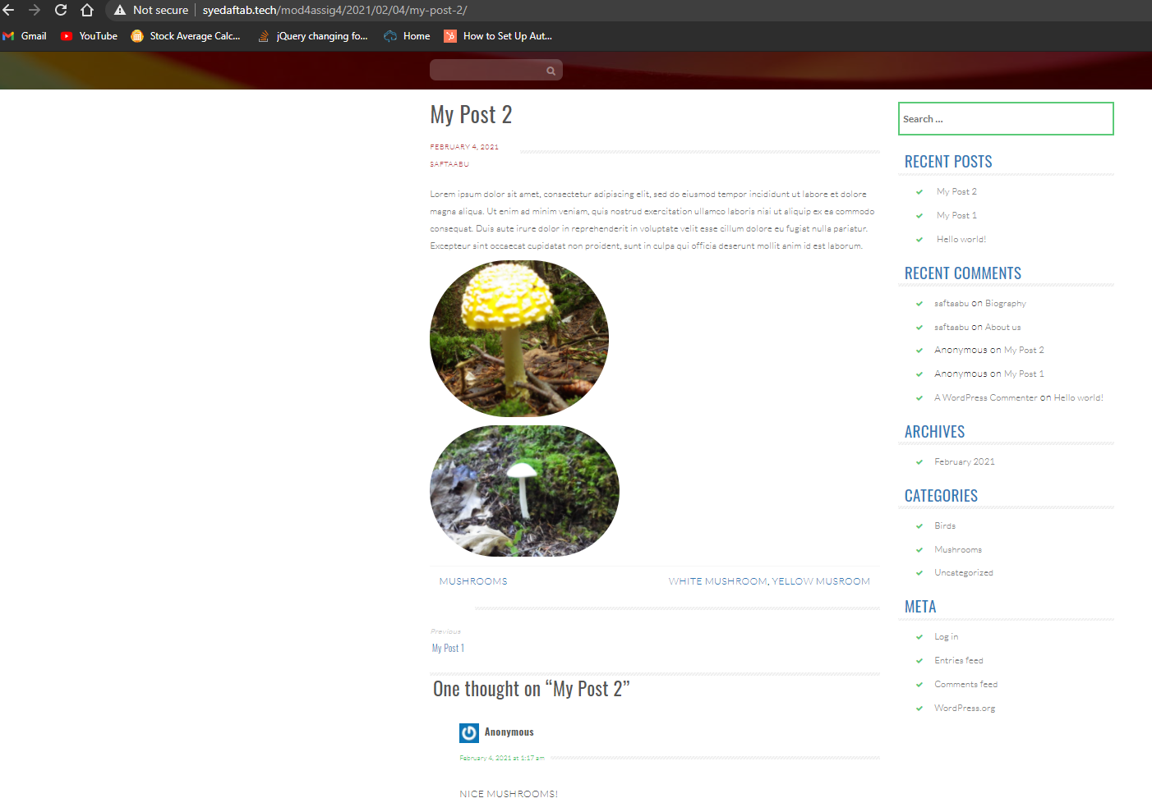]**

**Part D -** Codeanywhere – Demonstrate CMS Best Practices

1. Enter the following Codeanywhere web host account and WordPress site information. **[D.1]**
   1. Codeanywhere account username (email): [syedaftab299@gmail.com]
   2. Codeanywhere account password: [50297006@Sps]
   3. Website Admin Username: [ saftaabu]
   4. Website Admin Password: [ u$ed*Ylan4KkWJ&WB5]

**Note:** For full credit, your instructor must be able to login into your Codeanywhere account to start the container and then be able to login to your Codeanywhere WordPress site to test it.

### List the plugins you selected for feature analysis and review [D02] [[Slideshow CK](https://saxassign04-syedaftab299999760.codeanyapp.com/wp-admin/plugin-install.php?tab=plugin-information&plugin=slideshow-ck&TB_iframe=true&width=772&height=877) , [Slider, Gallery, and Carousel by MetaSlider – Responsive WordPress Plugin](https://saxassign04-syedaftab299999760.codeanyapp.com/wp-admin/plugin-install.php?tab=plugin-information&plugin=ml-slider&TB_iframe=true&width=772&height=877), Images Slideshow by 2J – Image Slider

### ]

1. Take a screen capture of your feature analysis report and paste it here  
   **[D03]**  
   **[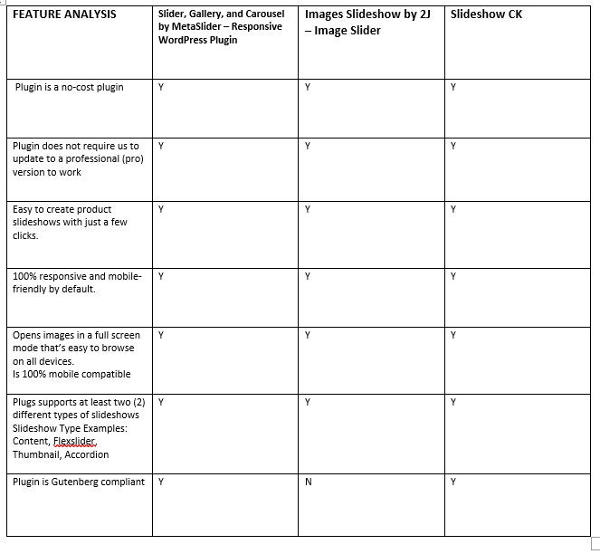]**
2. Record the name of the plugin you selected based best practices  
   **[D04]**  
   **[Slider, Gallery, and Carousel by MetaSlider – Responsive WordPress Plugin]**
3. Write a few sentences that describe the 4 best practices you used to select the plugin  
   **[D05]**  
   **[- Met all the requirements that was listed for the Slideshow features.**

* **Large installations and good reviews.**
* **Actively maintained as it was updated just 2 weeks ago.**
* **Compatible with my WordPress version]**

1. Backend SCREEN CAPTURE of the **Plugins** Page **[**Dashboard > Appearance > Themes**]** showing the active theme **[D06]  
   [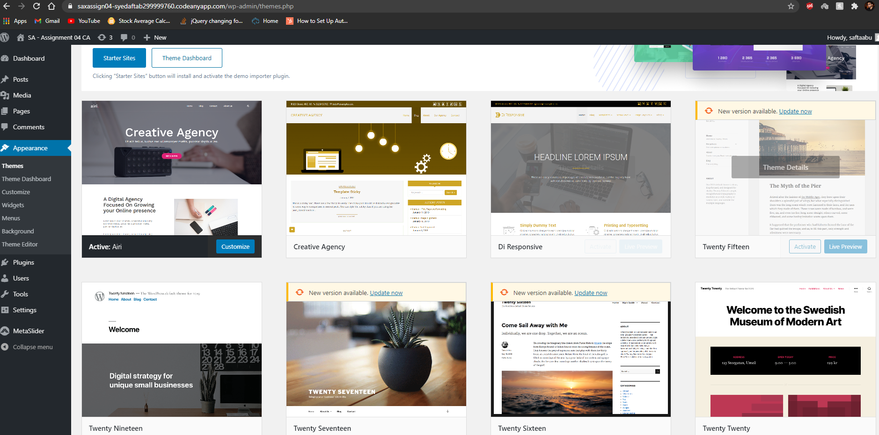]**
2. Backend SCREEN CAPTURE of the **Plugins** Page **[**Dashboard > Appearance > Menus**]** showing the created and configured Menu **[D07]  
   [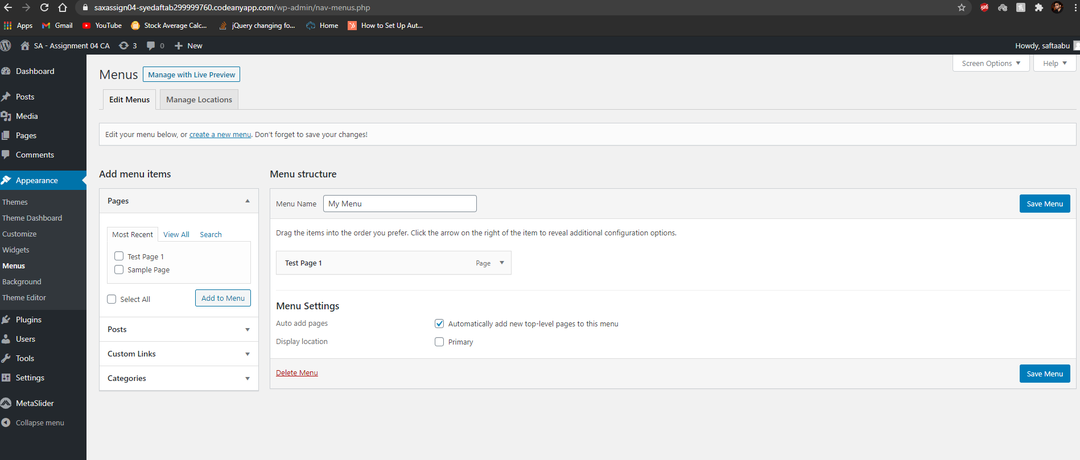]**
3. **Backend** SCREEN CAPTURE of the **Plugins** Page **[**Dashboard > Plugins**]** showing your Plugin you selected **[D08]  
   [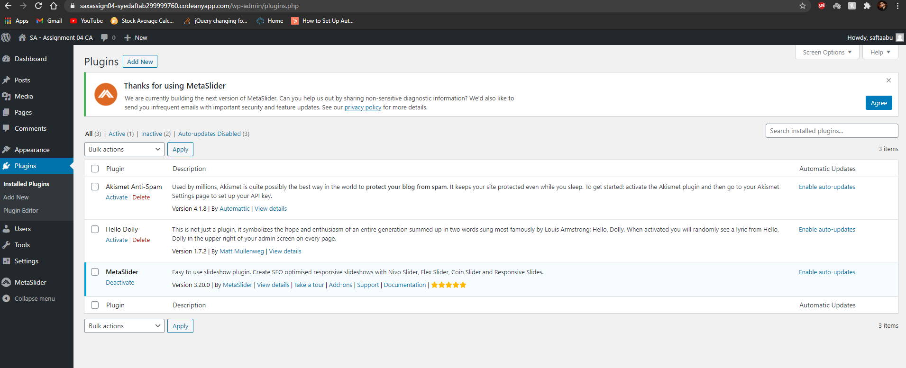]**
4. **Front-end** SCREEN CAPTURES of the implemented **Plugins** Pages  
   **[D09]**   
   **[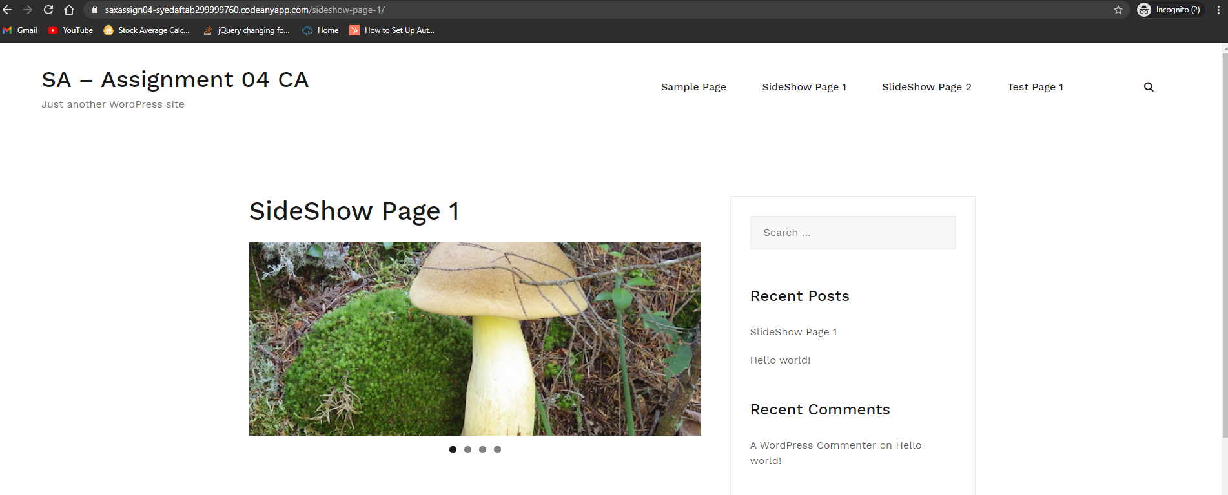 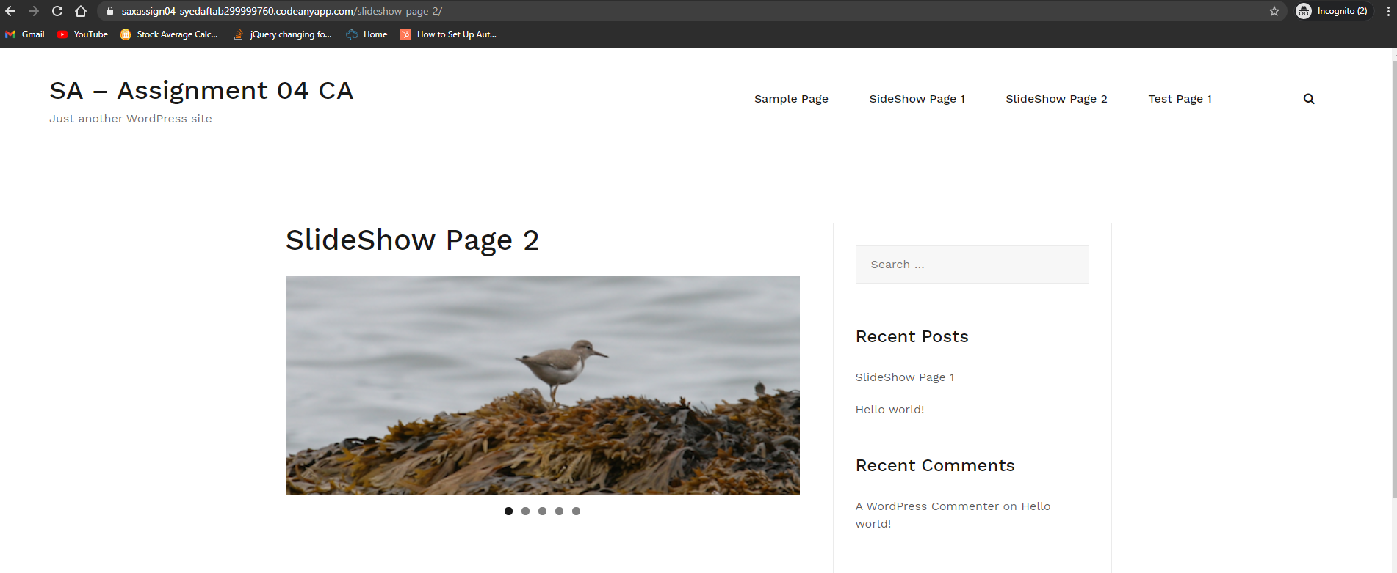]**

**Go back to the instructions and begin work on Part E.**

PART E: PHP   
**Testing PHP Programs using PHP Emulation Websites:**

* Online PHP test sites:
  + <http://phptester.net>
  + <http://www.writephponline.com/>
  + <http://sandbox.onlinephpfunctions.com/>
  + <https://wtools.io/php-sandbox>
* How you test your script depends on which test site you use.
* **Each PHP emulation test site works slightly different**.
* Please read the site instructions before testing your PHP code.

**HOW TO DO THESE TYPES OF QUESTIONS:**   
For more help on debugging and troubleshooting PHP errors, please refer to the Module 03 presentation “M03 -09- PHP Troubleshooting Coding Errors”.  
For Help with PHP classes and objects, refer to presentation “M04 -08- Introducing PHP Classes and Objects”.

1. Demonstrate that you can code a PHP class and instantiate 3 objects of that class, then add these class objects to an array, and iterate through the array displaying the object data member variable values in an HTML table. Please add at least 3 member variables to your class.   
   Write your PHP code in an ASCII editor and test and trouble shoot it using a web PHP emulator (tester).  
    When you have resolved all the coding issues, take a screen capture of the working code and output window.   
   When creating your class, please write your own PHP code.  
   Do not copy and paste IT320 provided PHP example code.

NOTE: This PHP code may be a little too much for PHPTester to handle. If you get errors and your code is correct, consider using another web emulator like writephponline.com or PHP Sandbox

**[E01]**

|  |
| --- |
|  |

1. Demonstrate that you can code PHP functions that use pass by value and pass by reference. Please write one PHP program (file) that has 2 functions, one pass by value, the other pass by reference. Please add 2 calls to each function and use echo statements to output display values.  
   Write and test your PHP code using a web PHP emulator (tester) and take a screen capture of the working code and output window.   
   When creating your PHP program, please write your own PHP code.  
   Do not copy and paste provided PHP example code. **[E02]**

|  |
| --- |
|  |

PART F: PHP and Custom Module

1. Take screen captures of the site folder, with the “**wp-content/plugins**” folder and custom plugin folder   
   **[F.1]  
   [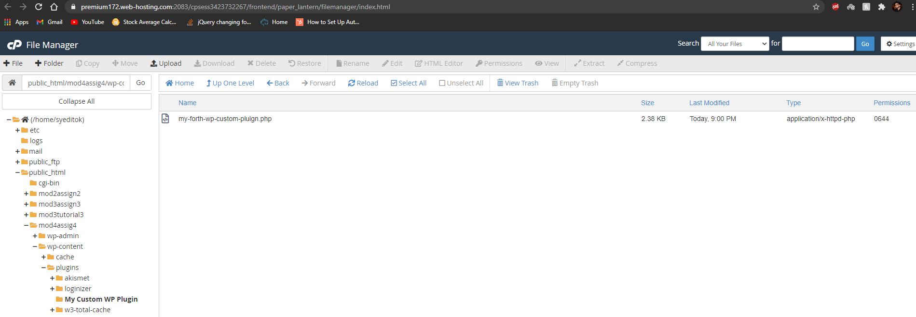]**
2. Take screen captures of the backend administration WordPress site Dashboard > Plugins showing the custom plugin enabled   
   **[F.2]  
   [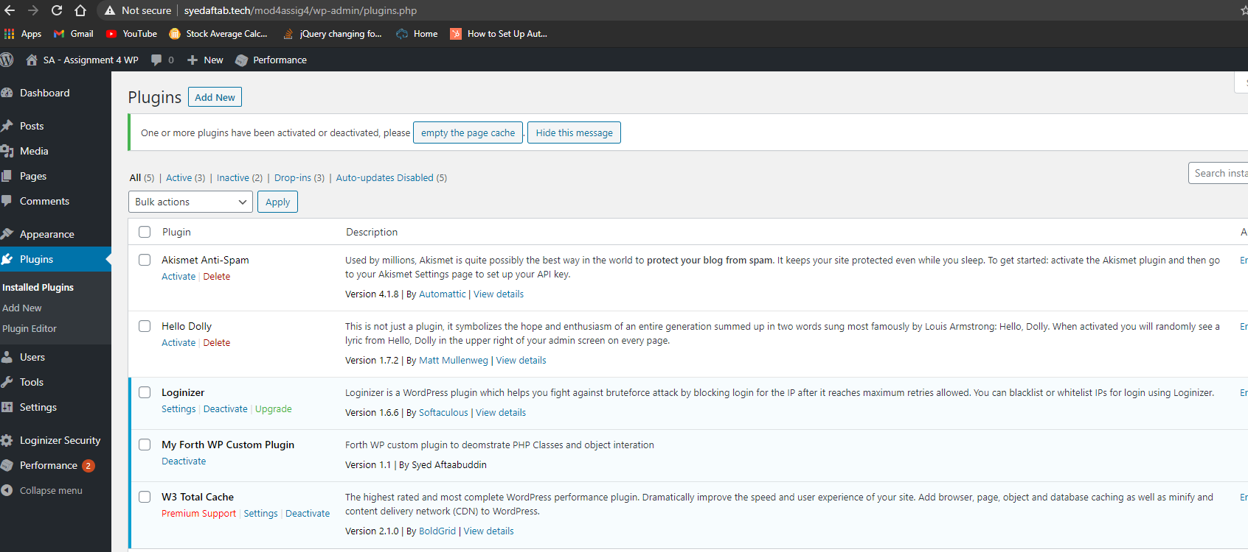]**

1. Take screen captures of the backend administration WordPress site Dashboard > Pages   
   **[F.3]  
   [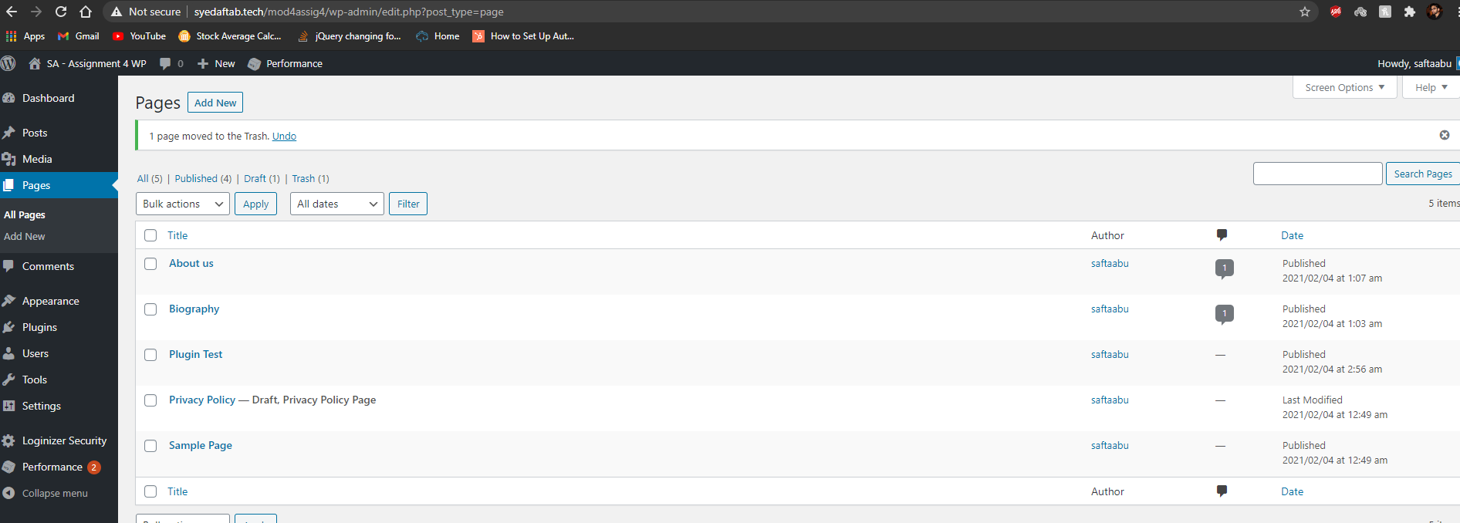]**
2. Front-end screen capture showing the Custom Plugin page display with the Main menu item and the web browser toolbar visible for full credit.  
   Please verify that your screen capture shows the web browser address bar   
   **[F.4]  
   [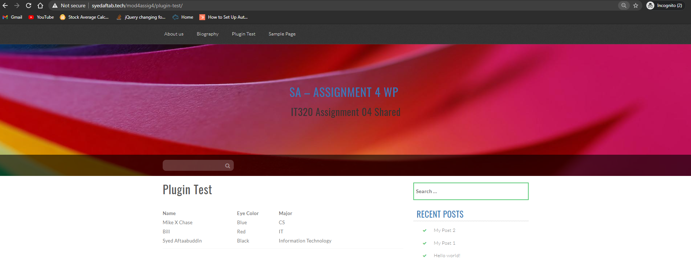]**
3. Screen Capture of your modified custom plugin code – You can split the images up, but you must display the entire program for full credit.   
   **[F.5]  
   [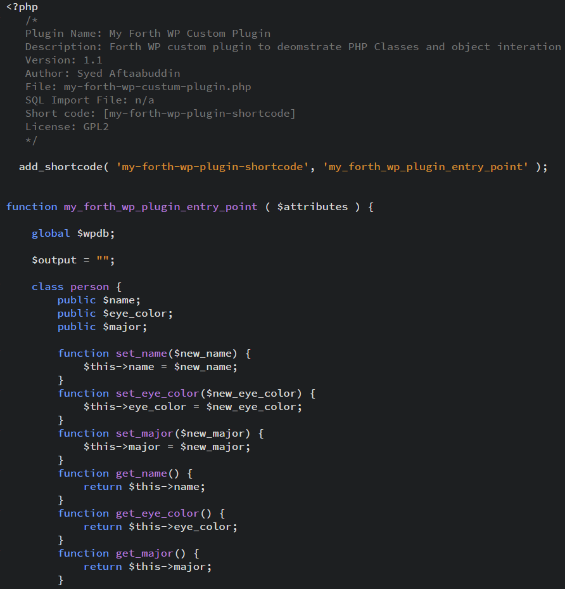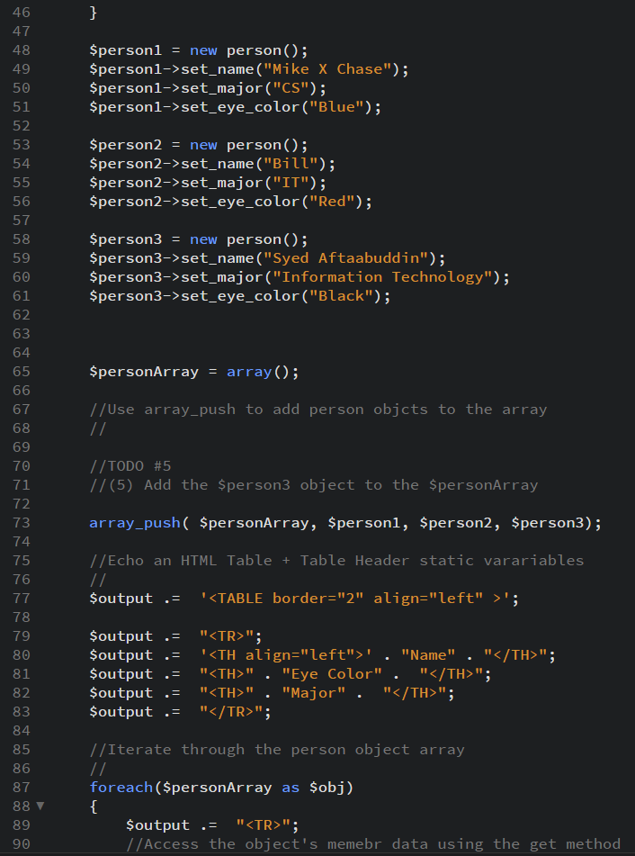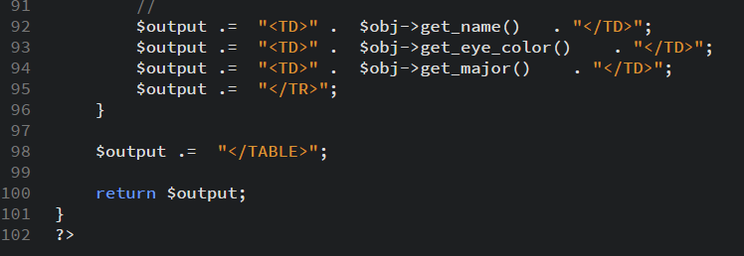]**

Go back to the instructions and continue with Part G.

**Part G – Assignment Wrap up:**

1. **Did you have any problem or issues completing this assignment?  
   This is not an optional question.   
   [**NO**] [G01]   
     
   If you answered yes to this question, please elaborate and be specific.  
   If you had trouble with a specific question, please identify it by number and explain what you did not understand or had problems with, especially if you left parts empty.  
   I can only improve this assignment with your help.**
2. **[**Elaborate your problems or issues here**]   
   [G02]**Required If you answered Yes to **[G01]** above or if you left one or more parts empty in the template.

Submit this completed template to the correct D2L assignment dropbox.If you prefer not to navigate by hand to the D2L dropbox, take advantage of the dropbox link in the D2L this module’s section. This link will take you to the correct assignment dropbox location.